MILDENHALL Treasure Trail Answers (No peeking until you have finished!)

- 16:30 – 22:30
- Milpets
- 10
- 1995
- War Memorial
- Baby Sumo Wrestler
- 800 years
- 32
- 105.3
- 13
- 1943
- Whale
- £30 or ?
- 10am – 4pm
- Mildenhall Parish Council

Well done and congratulations

Please return to the starting point *before 4.00pm to receive your ‘treasure’ or contact us via info@sharingparenting.com so we can send you your prize!

FIND THE FUN!
MILDENHALL
Treasure Trail

In order for you to enjoy this FREE treasure hunt you must THINK SAFETY FIRST:
- Children remain the responsibility of the parent/carer at all times.
- Refer to the most recent Covid-19 Government advice: https://www.gov.uk/coronavirus
- If you or any of your party have any symptoms of Coronavirus please do not take part and stay at home.
- Take care near roads, use pedestrian crossings and keep your children close at all times.
- Keep your distance from those outside of your household.
- The treasure hunt has been designed with any one way or safety instructions which were in place at the time of design but if these have changed since please do follow the most recent rules.
- Wash your hands and/or use hand sanitiser regularly especially if you touch any shared surfaces and/or eat or drink.
- You do not need to go into any shop or make a purchase to complete this treasure hunt, however IF you are going shopping at the same time remember you are required to wear a mask in the shops.
- There is no time limit on the treasure hunt as this will vary depending on the age and abilities of your children. Please note if this is after 4.00pm please contact Sharing Parenting for your prize.
- Contact point for Sharing Parenting on the day:
Rich, Telephone: 07717 744608.

Let’s get started!
Go to the starting point which is Precinct (near Crumbs Café) IP28 7EF

Take a selfie of you and your group

- What are the delivery service hours for Sunrise Chinese Takeaway?

- What is the name of the pet shop?

- How many cards can you get for £1 from Card Factory?

- What is the number on the lamp post by the entrance to Lloyds Pharmacy?

- On the Mildenhall High Town Map, what is on the triangle where Kingsway and King Street meet?

- What picture is on the logo for Sumo Sushi?

Cross over the Zebra Crossing and head towards the Church

- How many years has St Mary’s Church, Mildenhall, been open?

- What is the door number for Spice Lounge Indian restaurant?

Carefully cross the road and head towards the Zack FM building
- What frequency is Zack Radio on?

- What number is on the green BT box by Aphrodite Beauty?

Turn right and walk up towards Wilko’s
- What year was the St Andrew’s Café established?

- What sea creature is on the mural painting on the side of the Tattoo Studio?

- How much is a Wilko BBQ Kettle Grill? Or what is in the shop window?

- What is Sainsbury’s opening hours on a Sunday?

- Who maintains the playground near Sainsbury’s?

Well done Now you have completed the treasure hunt please return to the starting point *before 4.00pm to receive your ‘treasure’ or contact us via info@sharingparenting.com so we can send you your prize!

You can download your certificate from our website https://www.sharingparenting.com/2020/07/07/bring-on-the-summer/

It would be great if you can post your selfies of your treasure hunt on your Facebook page and tag us @sharingparenting and add #Sharingparentingfindthefun

You can also add your selfie (or a photo of your child’s picture) on our online board https://padlet.com/ginny13/ezyoseykdbtsk7ba
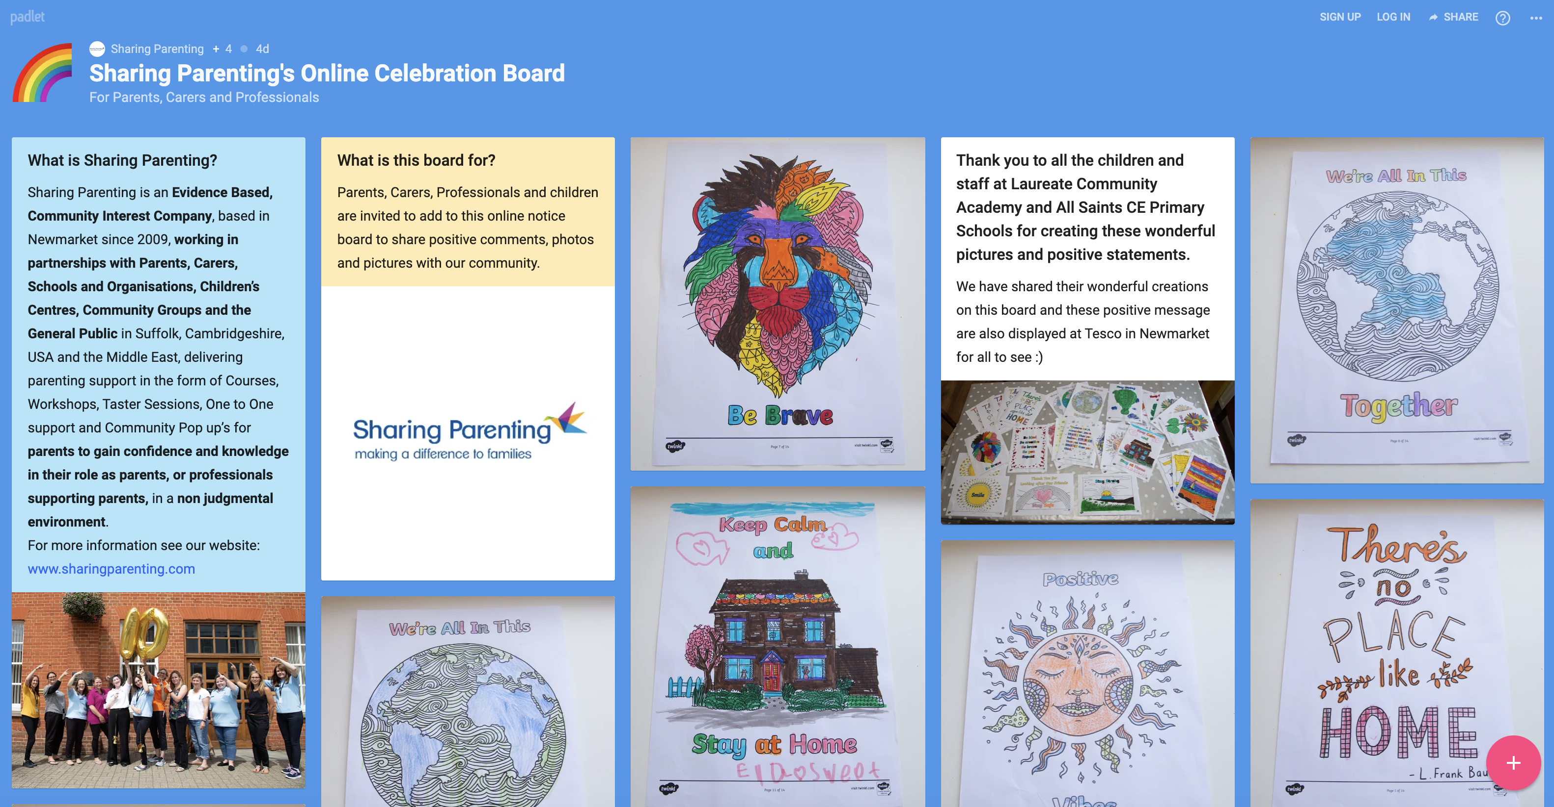

www.sharingparenting.com Telephone: 07867 568339

